**Day 1**

**Tweets gathered =51**

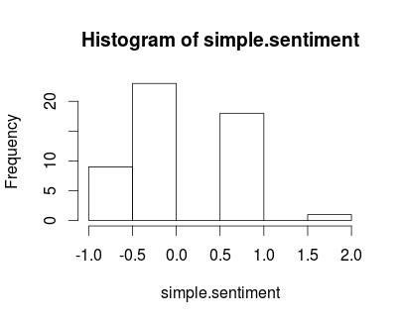

**Day 2**

**Tweets gathered = 169**

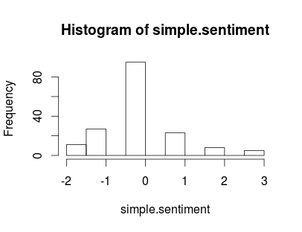

**Day 3**

**Tweets gathered = 100**

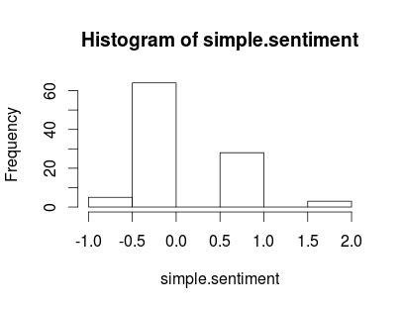

**Day 4**

**Tweets gathered =200**

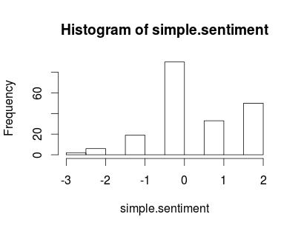

**Day 5**

**Tweets gathered = 200**

